RDMAC Incident Report Form
Date / Time | Name of Pilot | Phone Number

Weather Conditions

Wind strength and direction
See reverse for Beaufort Scale

If submitting completed document via email, please indicate on the diagram below the approximate location of the incident by using the ‘Insert’, ‘Shapes’, ‘Block Arrow’ function in MS Word

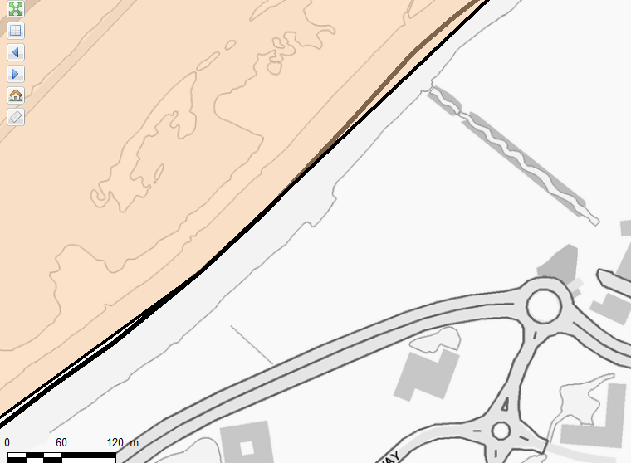
Hedge
River Thames

Describe what happened and what you and / or the pilot believe to be the cause
Please include any relevant observations from fellow pilots

Model and Equipment
Type of model e.g. fixed wing trainer
Make and model of radio
Frequency in use
Engine make and capacity

General Questions
Was frequency in use at the time?
Do you hold a BMFA ‘A’ certificate?
Were you a pilot under instruction at the time of the incident?
Approximately how long have you been flying model aircraft?

Please note the name and address of any injured persons and describe their injuries

Post-Incident Investigation
Note down any features of the damaged aircraft that may have caused the incident
Note down any actions on your part that may have caused the incident

Beaufort Wind Strength |  | MPH
1 |  | 1 – 3 | Smoke just begins to move with the breeze
2 |  | 4 – 7 | Leaves rustle slightly
3 | Limit for training | 8 – 12 | Small branches sway and smoke moves horizontally
4 | Good for slope soaring | 13 – 18 | Loose dust or surface sand is stirred and large branches sway
5 | Limit for power flying | 19 – 25 | Surface waves begin to form on water
6 |  | 25 - 31 | Trees begin to bend with the force of the wind

Please email completed form to Andy Warlow at andy.warlow100@gmail.com or hand in to a committee member at the flying field

